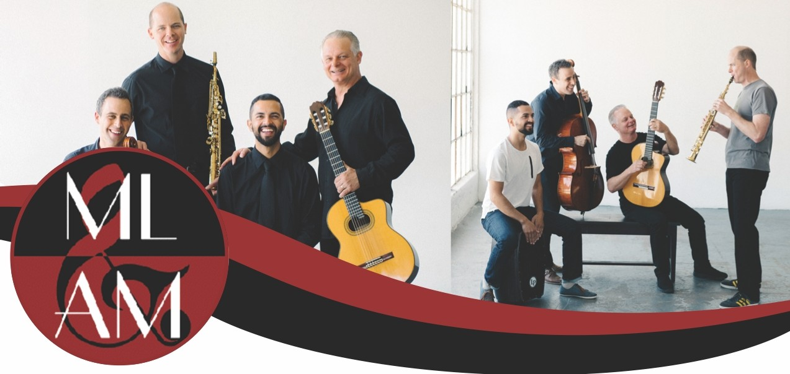

Workshops and Clinics by Quarteto Nuevo!
Quarteto Nuevo combines the talents of Damon Zick (woodwinds), Jacob Szekely (cello), Kenton Youngstrom (guitar) and Felipe Fraga (percussion), to offer young musicians some of the most innovative programs in the world! The group's commitment to the creation of original music and the education of students is evidenced by the hundreds of workshops given across the U.S for enthusiasts young and old! Workshops vary in length from 45 to 90 minutes. Quarteto Nuevo works with your educators to tailor the content and format of each class to meet their specific needs. Here are some suggestions:

Improvisation: A Multi-Cultural Approach (General Workshop for all instruments)
This workshop introduces students to various approaches to improvisation from around the world. All instrumentalists are encouraged to participate as the members of the quartet demonstrate techniques for expanding students' musical horizons.

Open Rehearsal and Performance with Quarteto Nuevo (General Workshop for Middle and High School Students) Have your band or orchestra sit in with Quarteto Nuevo! Members will explain how and why certain musical decisions are made within a chamber group and will share effective rehearsal and practicing techniques.
Breaking Expectations (General Workshop for Middle and High School Students)
This workshop will cover the history of Quarteto Nuevo as well as the group's philosophy and mission as a performing ensemble. Acoustic musical examples will be used to demonstrate the structure and style of original compositions, and to engage students in active listening and analysis exercises. The group performs several of their tunes and the session closes with a question and answer session.

Why Quarteto Nuevo: The diversity of stylistic and instrumental backgrounds allows Quarteto Nuevo to offer 45-90 minute workshops to high school and college guitar, band, jazz and orchestra students. The group is capable of teaching in a wide variety of styles from Classical and Jazz to Brazilian and other World styles. The members of the quartet are world-class educators in their own right with over 80 years of combined teaching experience as professors at The Colburn School, Pepperdine University, University of Redlands, Cal State Fullerton, Pasadena City College and String Project Los Angeles, and have lectured at major institutions including The Berklee School of Music, UCLA, Oklahoma State University, Cal Arts, Barcelona Conservatory and the Hong Kong Academy for Performing Arts, and have presented workshops and master classes for The American String Teachers Association {ASTA), The Jazz Educators Network Conference (JEN), IAJE, American Guitar Congress, and are published in The Strad, Strings Magazine, the Hot Licks Series and Frets Magazine, among others.

Workshop Formats:
Quarteto Nuevo offers workshops and clinics in the following formats:
- Quarteto Nuevo as a group
- Individual workshops: the members can work individually or in teams with different school ensembles including band, orchestra, drumline, percussion, guitar and jazz ensembles.

AV Requirements:
- 1 Wall Projector (HDMI Input)
- 1 Projector Screen (or White Wall)
- 3 music stands
To schedule a workshop or for more information, please contact marian@marianliebowitz.com or phone (619)988-0751

